**SCREENSHOTS:-**

* **AWS LOGIN:-**

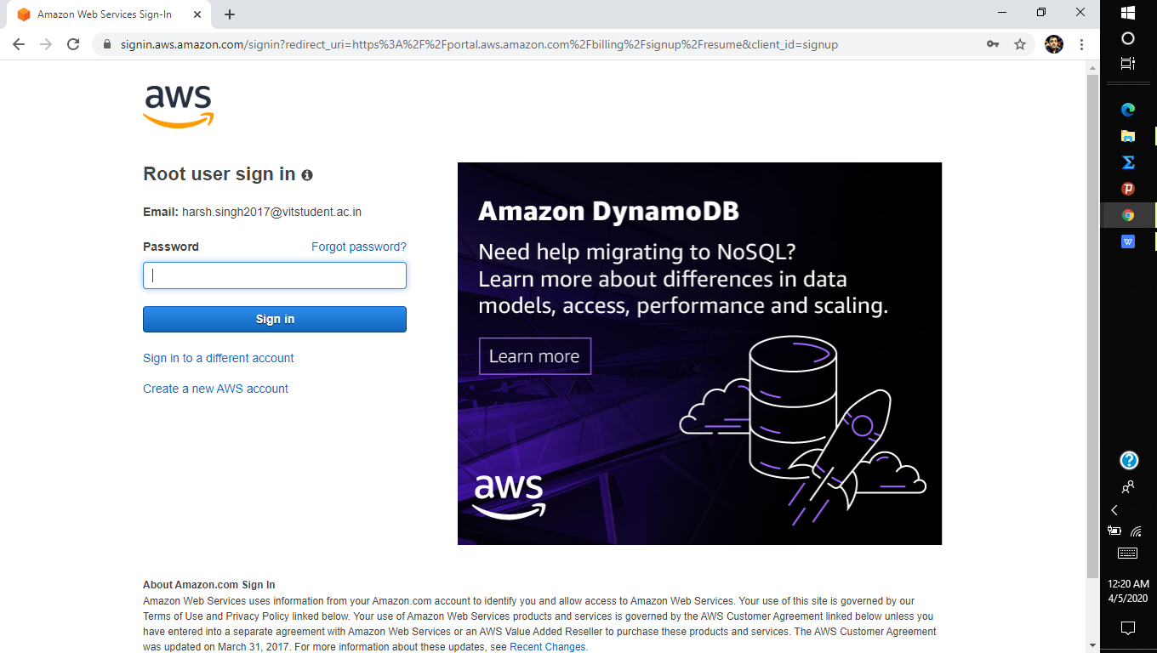

* **EC2:-**

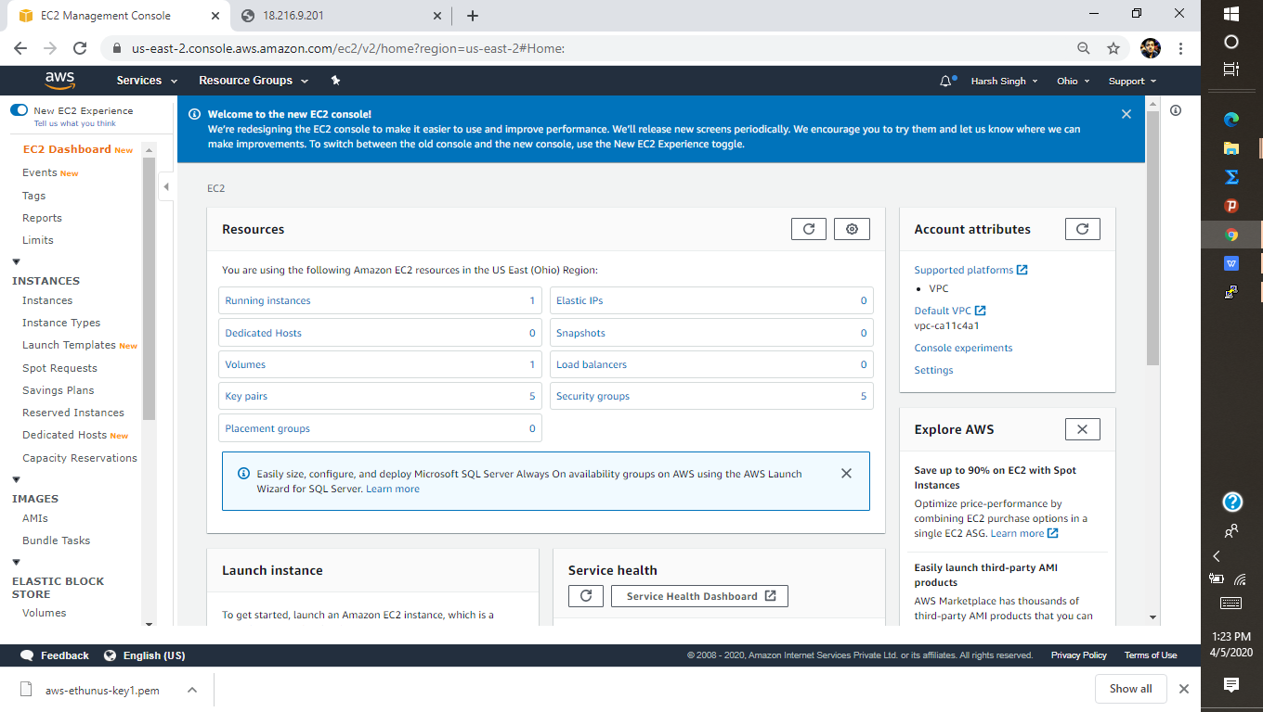

* **S3:-**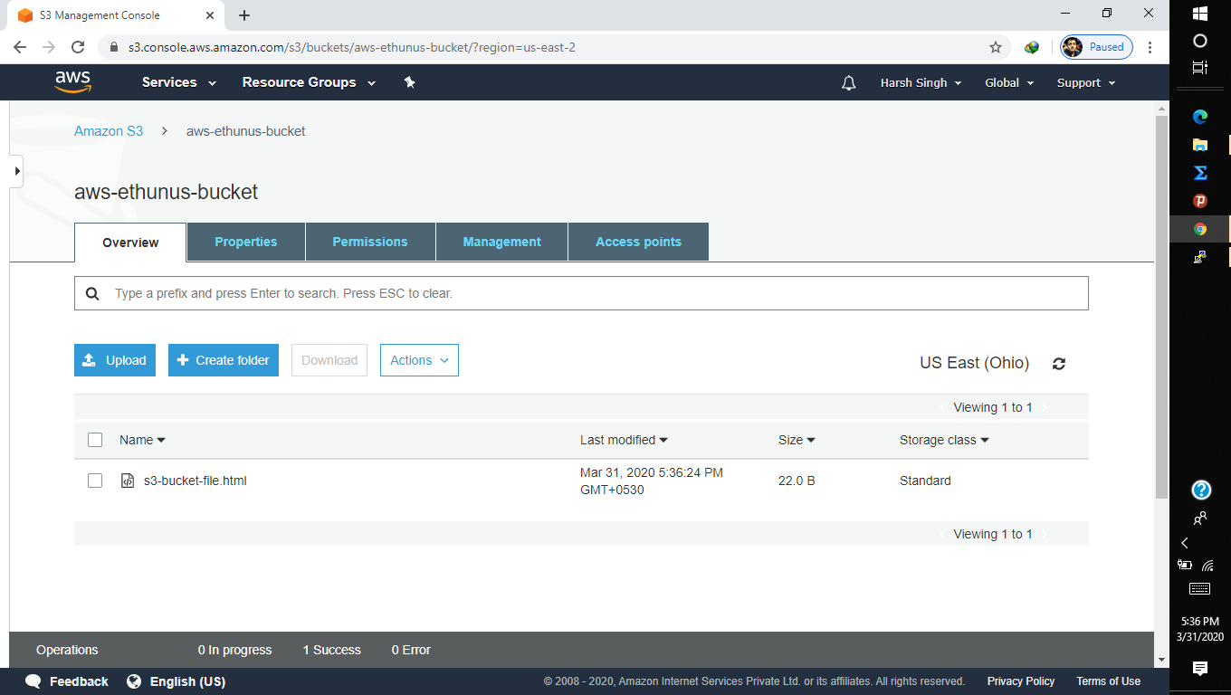
* **REKOGNITION:-**

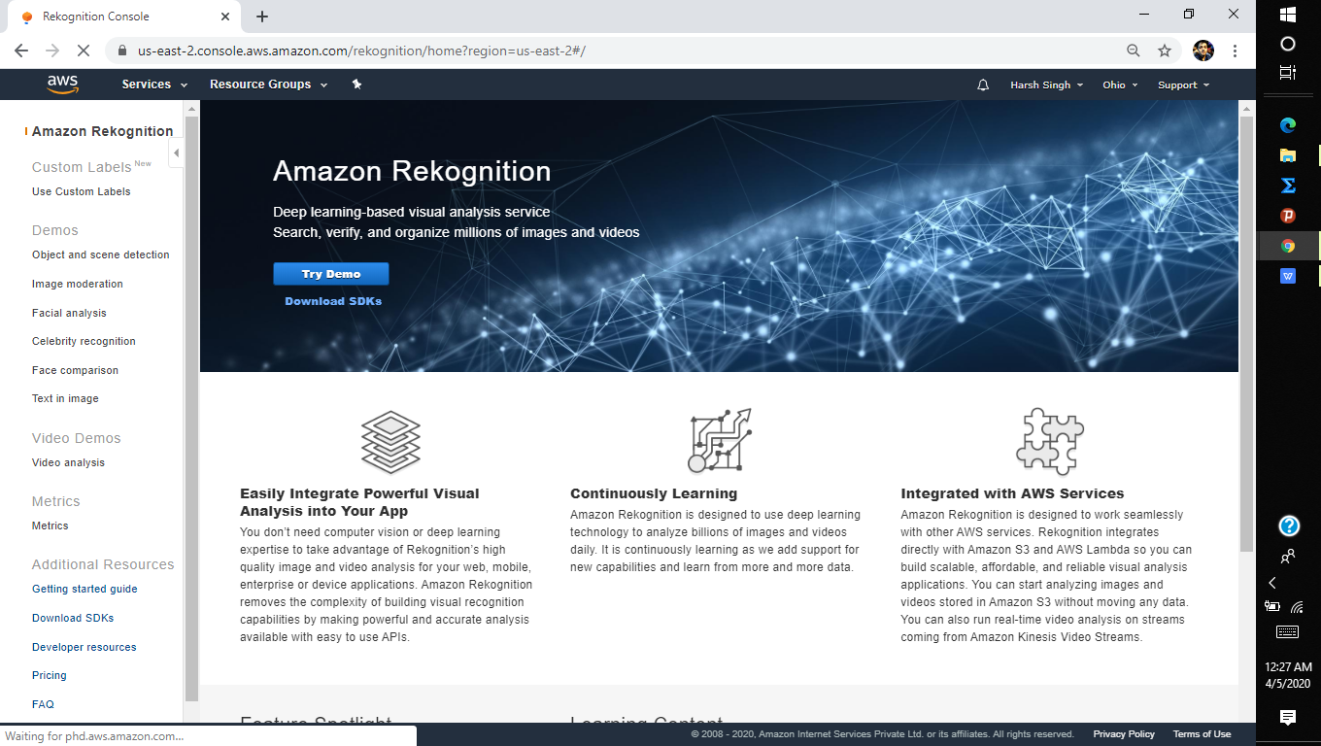

* **AMAZON MACHINE IMAGE:-**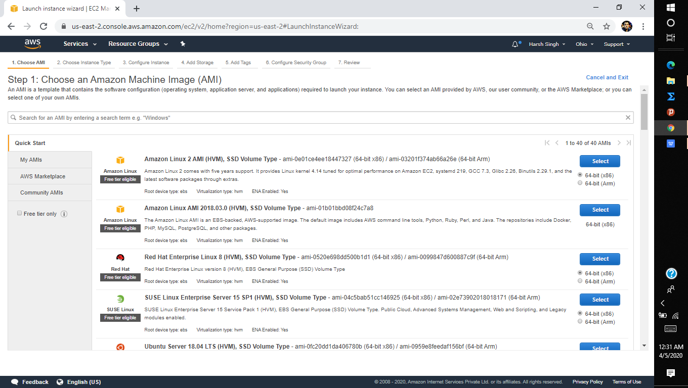
* **INSTANCE TYPE:-**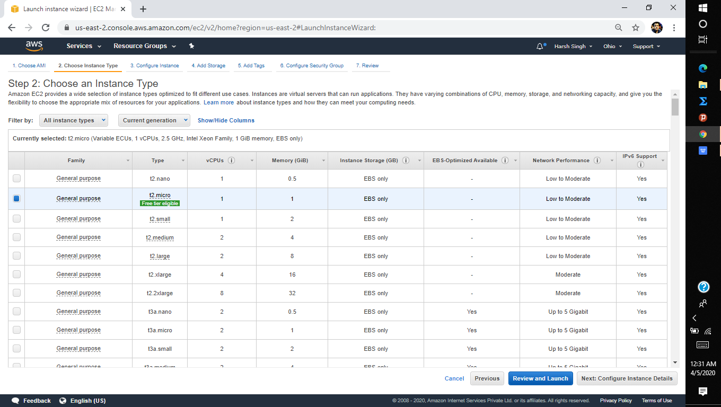
* **ADD STORAGE:-**

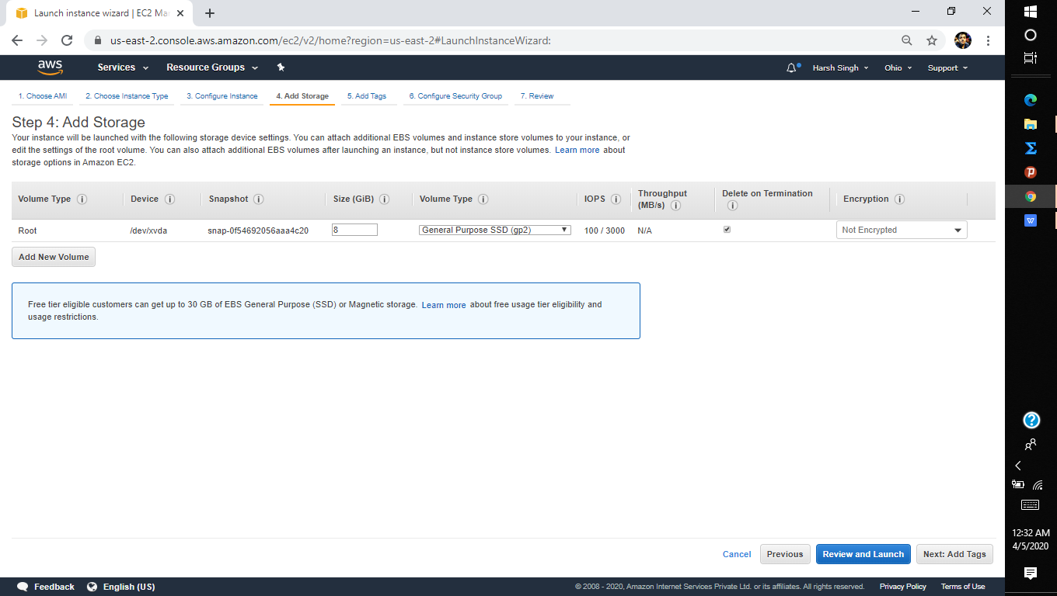

* **CONFIGURE SECURTIY GROUP:-**

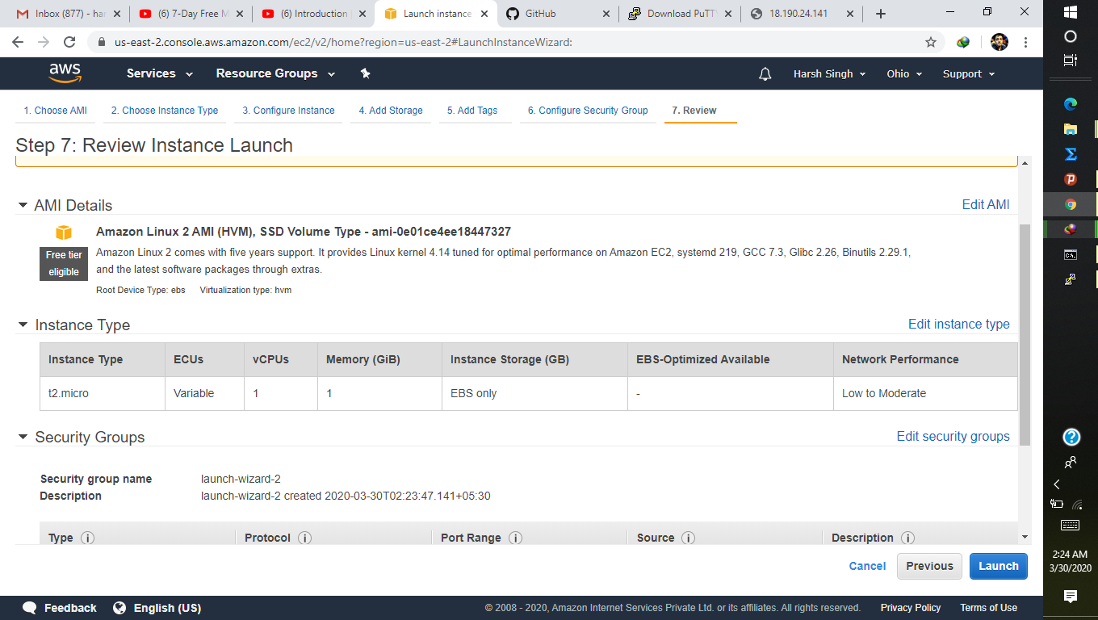

* **KEY-PAIR:-**

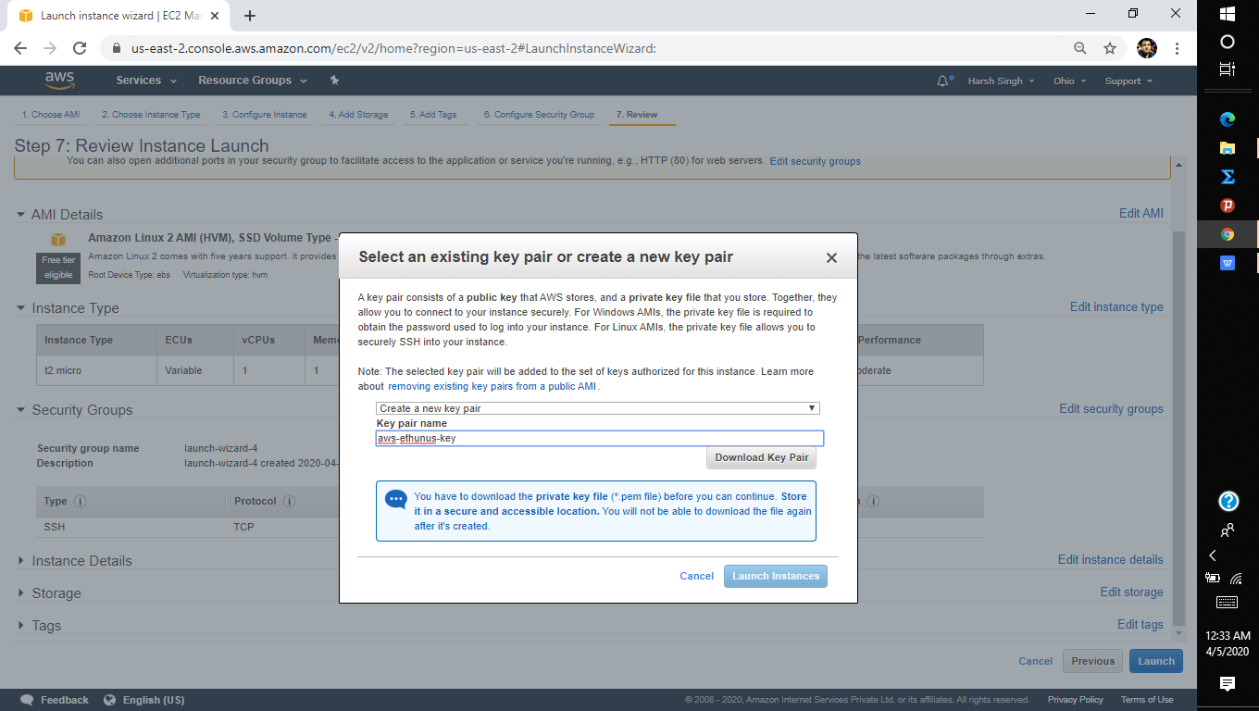

* **PUTTYGEN CONVERSION:-**

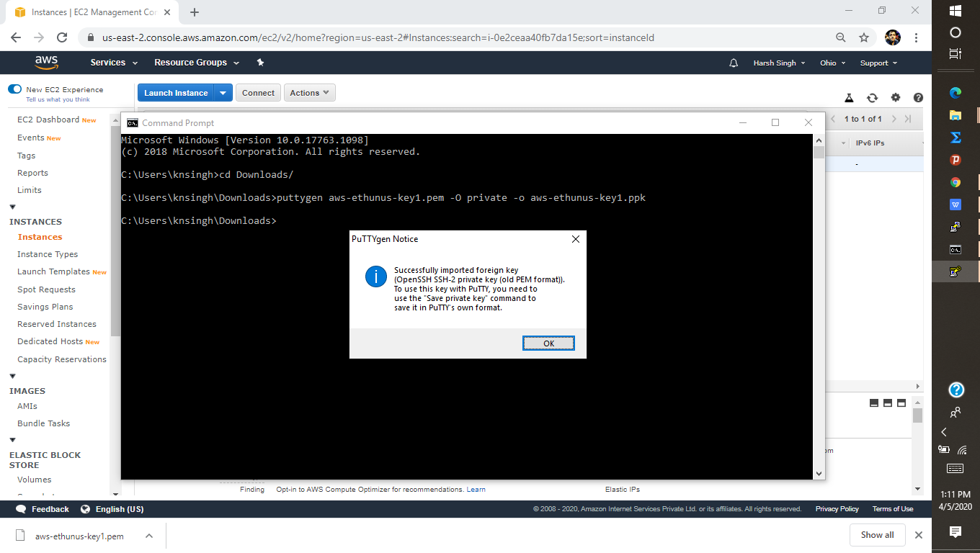

* **LOGGED IN EC2:-**

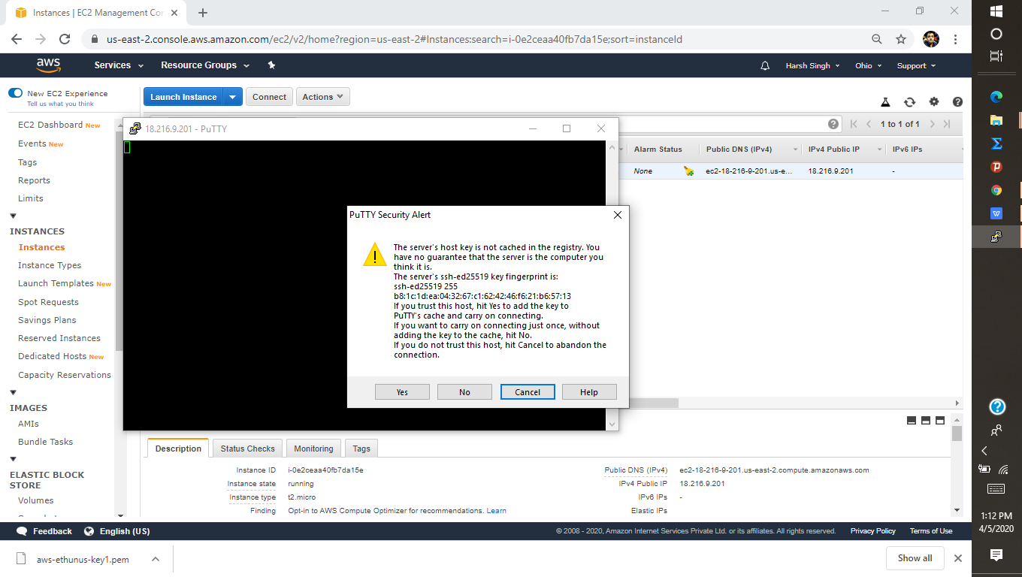

* **CREATING A BUCKET:-**

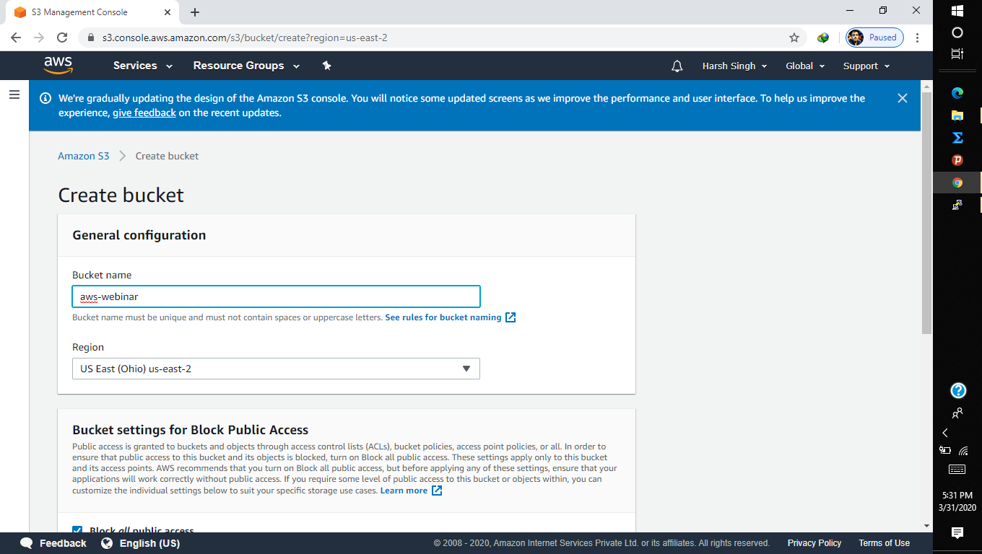

* **UPLOADING AN OBJECT:-**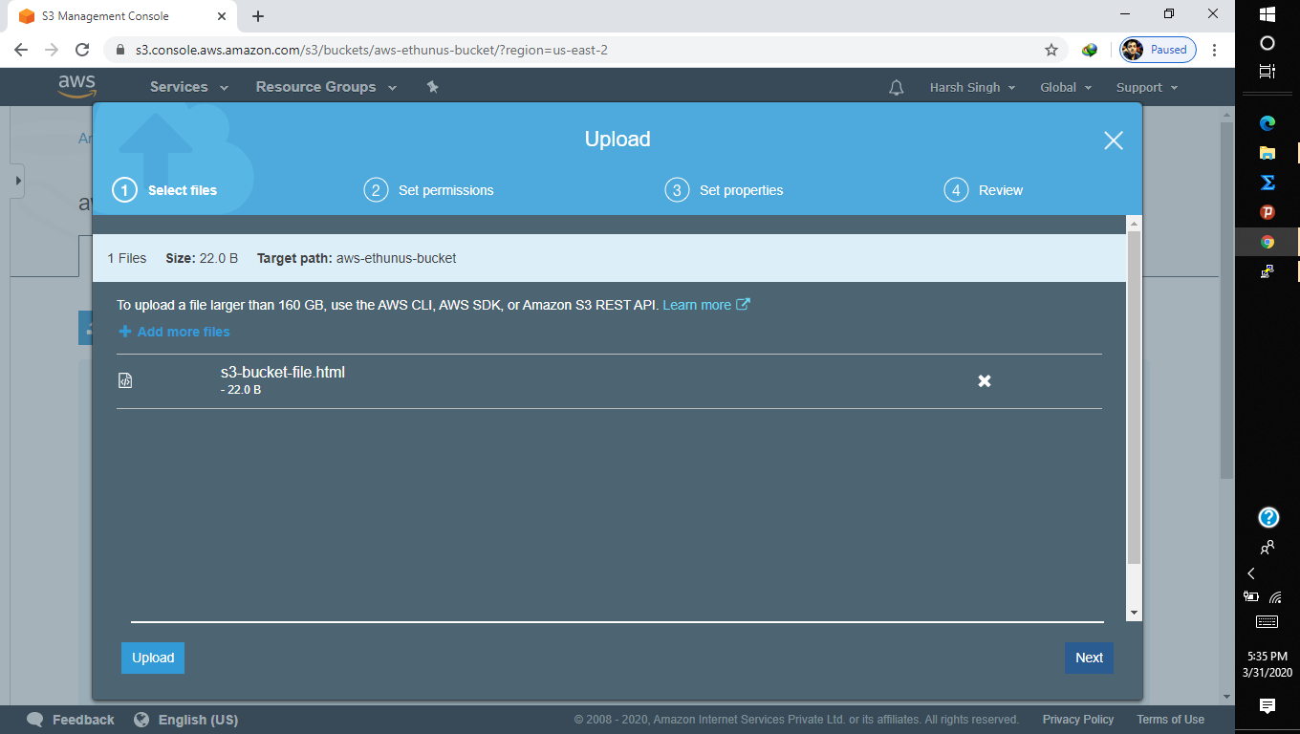
* **ENABLING STATIC WEBSITE:-**

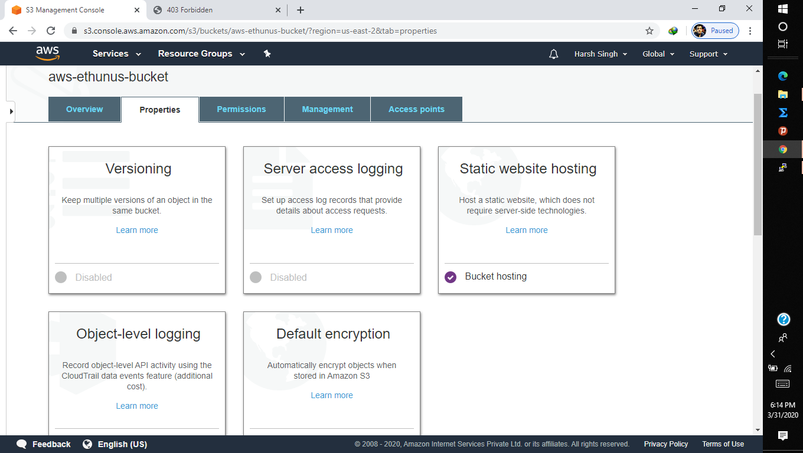

* **MAKING PUBLIC:-**

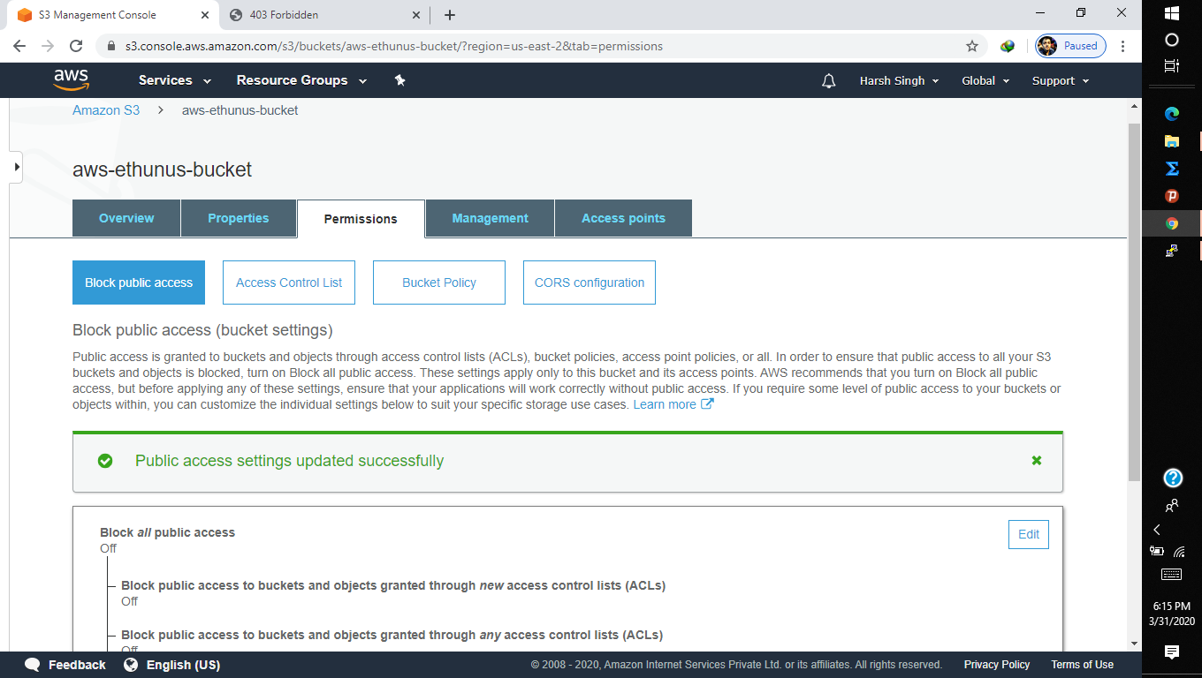

* **CREATING S3 LINK ON THE BROWSER:-**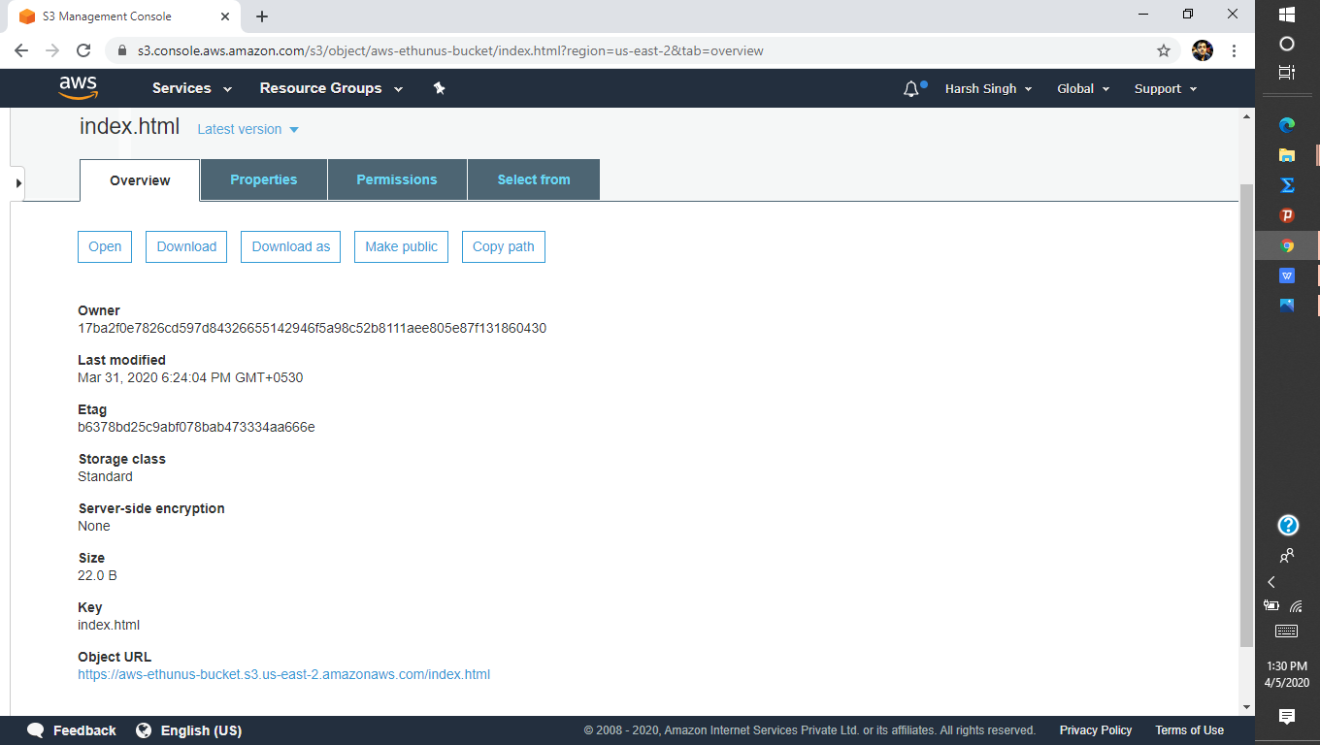
* **FACE DETECT:-**

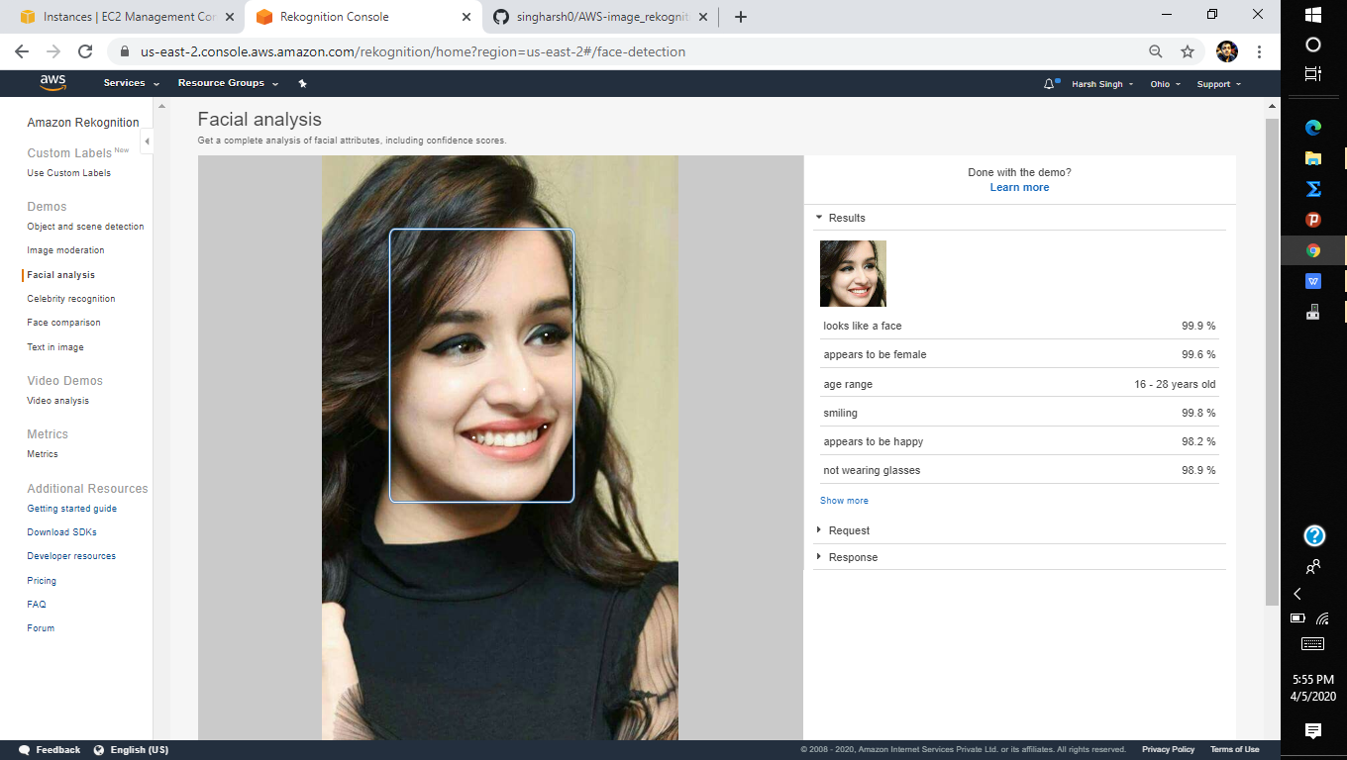

* **FACE COMPARISON:-**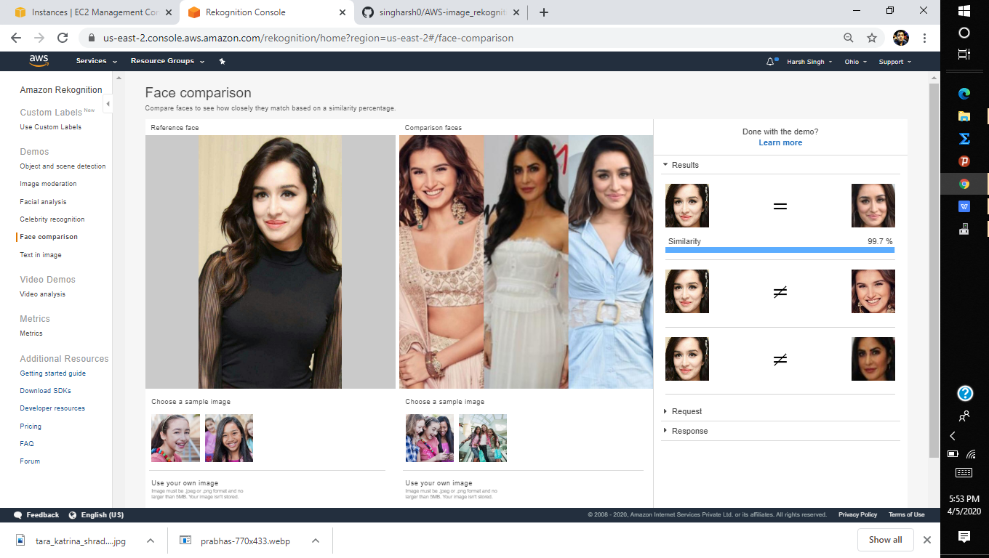
* **CELEBRITY RECOGNITION:-** 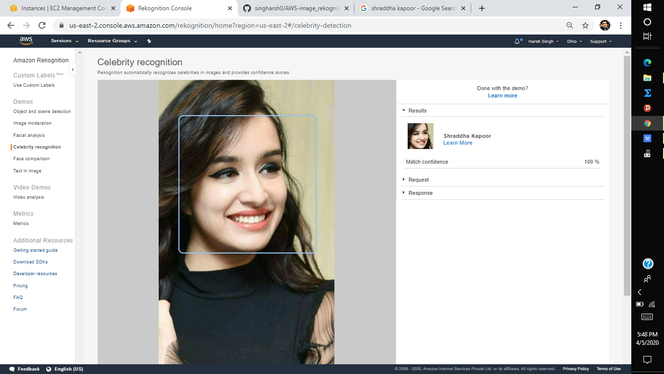

**TEXT IN IMAGE:-**

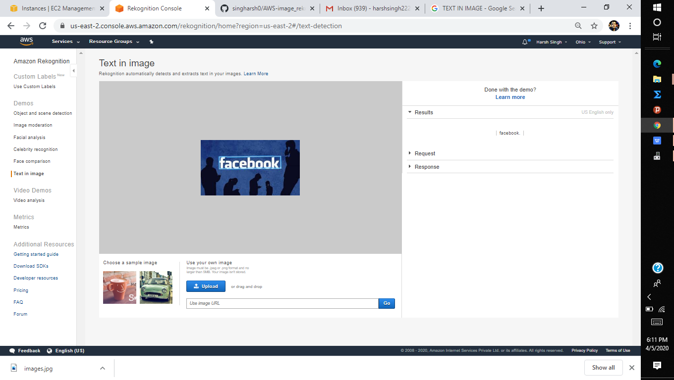

* **INSTALLING AWS-SDK:-**

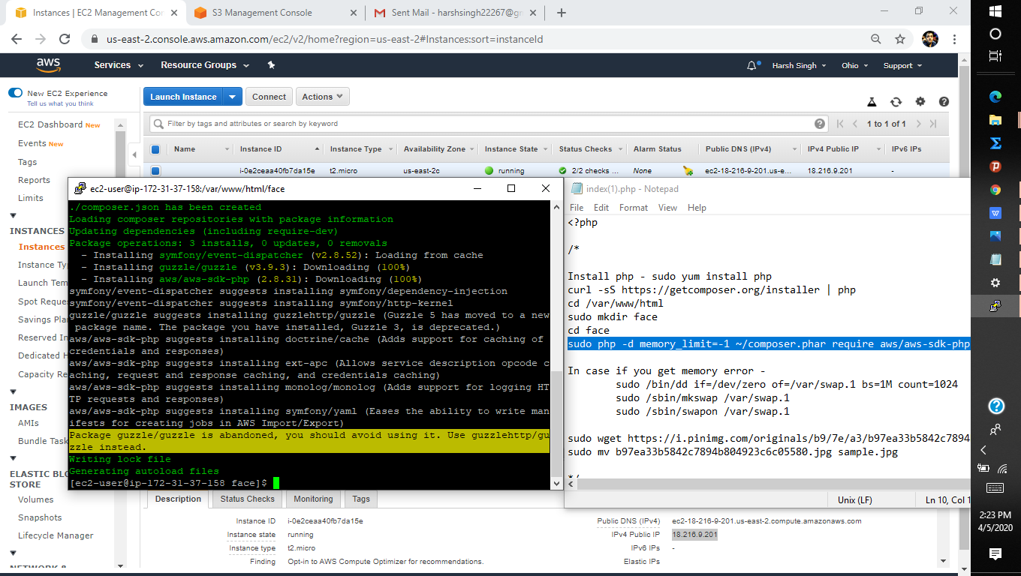

* **INSTALLING PHP:-**

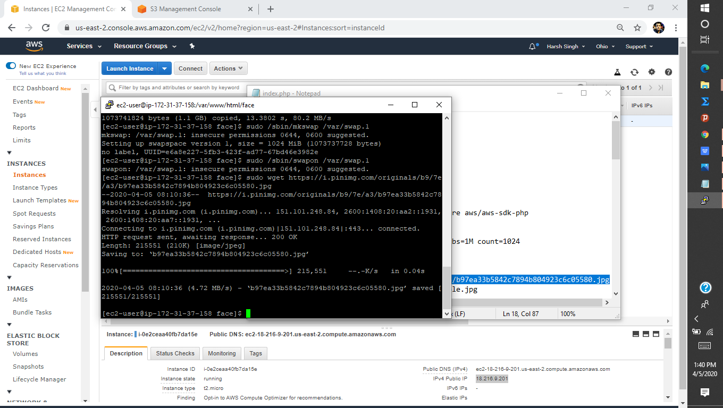

* **INDEX.PHP FILE:-**

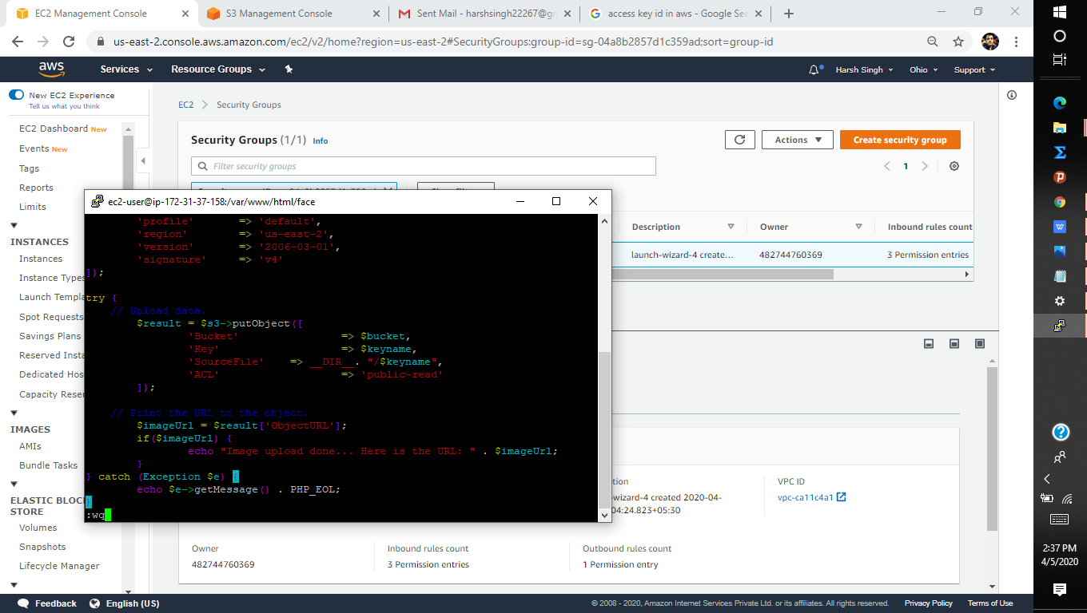

* **UPLOAD SCREESHOT:-**

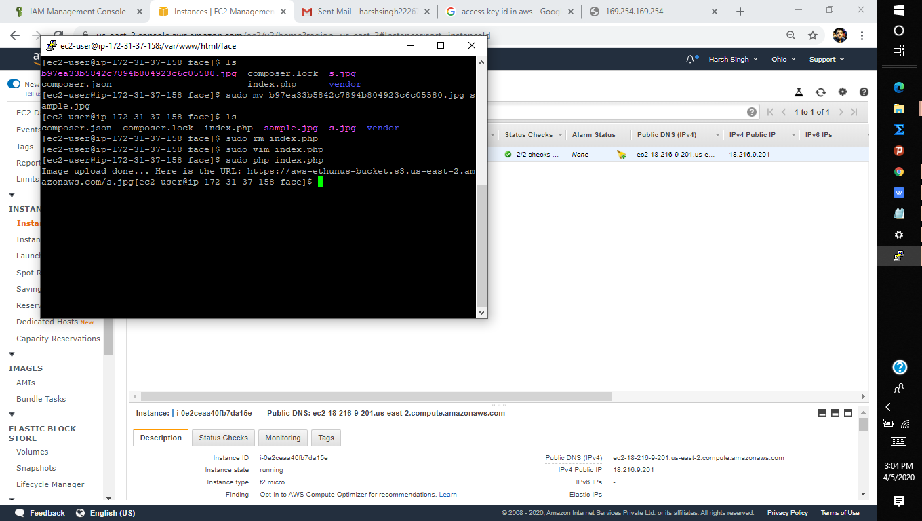

* **FACE DETECT SCREENSHOT:-**

